READING: Space Shuttle Overview
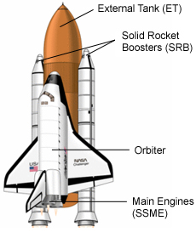
The solid rocket boosters and the three main engines work together to launch the Shuttle system into space. The external fuel tank provides both liquid oxygen, which is an oxidizer, and liquid hydrogen. These are blended together to burn in the main engines. The solid rocket boosters use solid fuel. Once the solid rocket fuel is completely gone and the liquid main engine fuel is gone the external tank and the SRBs are dropped (jettisoned) from the orbiter and fall back to Earth to land in the ocean.

The External Fuel Tank (ET)
The External fuel tank provides the fuel for the Space Shuttle main engines. It takes a lot of fuel to get out of the Earth’s atmosphere. The Shuttle (orbiter) does not have enough room to hold all of this fuel so it uses an external fuel tank. After the fuel is used, the external tank is jettisoned and burns up as it falls back to Earth.

Solid Rocket Boosters (SRB)
Did you know?
The Space Shuttle System has three parts: Solid Rocket Boosters (SRB), External Tank (ET), and Orbiter. The orbiter is often called the Space Shuttle or just the Shuttle.
The names of the Orbiters
- Discovery
- Endeavour
- Atlantis
- Challenger
- Columbia
The Solid Rocket Boosters are two rockets attached to the sides of the External Tank (ET). These are used to help lift the Space Shuttle into space. After they have been used, they fall off the Shuttle into the ocean. The SRBs are recycled to be used on later missions.

Space Shuttle Main Engines (SSME)
The orbiter has three (3) engines (rocket motors); each one is about 8 feet wide and 14 feet tall. They are about the size of your living room. The orbiter does not have an internal fuel tank for the main engines. These engines are used to get the orbiter into space and are not used after it gets there.

